PROJECT PLAN FOR TRAFFIC-SIMULATOR

Project Plan by



Group B

Todor Tsekov (2228777)

Wen Zhang (2351420)

Jiaqi Ni (2217774)

Yidi Wu (2197301)

Kalina Petrova (2221667)

Jianfei Feng (2204529)

Class: EI7s1/s2

Course: Project C-phase

Mentor: Bert Van Gestel

Final Version, 11 March, 2015

Fontys University of Applied Science

Eindhoven, the Netherlands

Table of Contents

Chapter 1: Introduction 3

1.1 Back group of the project 3

1.2 General introduction. 3

Chapter 2: Project Statement 4

2.1 Formal Client 4

2.2 Project Leader 4

2.3 Current Situation 4

2.4 Project Justification 4

2.5 Project Product 4

2.6 Project deliverables and non-deliverables 5

2.6.1 Deliverables 5

2.6.2 Non-deliverables 5

2.7 Project Constraint 5

2.8 Project Risk 6

Chapter 3: Project Phasing 7

3.1 Phases 7

3.2 Project Timeline 8

3.3 Milestones 9

Chapter 4:Management Plan 10

4.1 Money 10

4.2 Skills 11

4.3 Quality 11

4.4 Time 12

4.5 Organization 13

4.6 Information 14

Introduction:

## 1.1 Back group of the project.

Mr. George (our client) is working for the city of C#. He is primarily responsible for the traffic situation. Recently the city has endured a lot of accidents and because of this Mr. George wants to place some traffic-lights, in order to diminish the number of accidents. Before doing that, he wants to investigate whether these traffic-lights will not cause too many traffic-jams. In other word he needs a traffic-simulation program.

In order to build such a program, Mr. George find us and we are very happy to take over the job.

## 1.2 General introduction.

In this project, we are going to make an application which will simulate some different kinds of traffic situation.

Project Statement

## Formal Client

For this project, our Formal client is Mr. George who’s working in the city hall, after we interview him, he wants us to build a traffic lights application to change the traffic situation in the city.

## Project leader

Todor Tsekov is the project leader of Prophtech. He is currently studding at Fontys University Eindhoven.

## Current Situation

Until now, we know because of no traffic light, there are a lot of accidents happened and it also make plenty of traffic jam. Now, we are thinking about to build a traffic light program to adjust car-streams.

## Project justification

Because of a lot of accidents and traffic jam happened in Mr. George’s city, so he want to find someone to help him built a traffic light program to reduce these things happen.

## Project product

The goal of this project is to reduce the accidents and avoid traffic jam that will keep track of

1. Change the car-streams of every feeder lane
2. Adjust the ‘green ’ time of the traffic light

## Project deliverables and non-deliverables

Deliverable:

1. An application to limit car-streams and change the traffic light for cars and pedestrians.
2. User Manual.
3. Design layout.
4. Documentation and reports.

Non-Deliverables

1. Training for the use of the application
2. Any other services
3. Employees working with the application

## Project constraints

* Considering the fact that all of our team members are more familiar with C# than other programming language, we decided to use C# to make this application.
* It will take us about 14 working weeks to complete the whole project. (Including researching designing, implementing, testing, releasing).
* We only have limited meeting with our client. (Probably at the start and the ending of the project.)

Decisions:

* During the whole project, we will have meetings with our tutor every week to keep track of our progress and help us improve the product.
* In the 10th week (latest in the 11th week) there should be a prototype.
* In the 13th week (latest in the 14th week) there should be a release version.
* At the end of the project, we will make a presentation to show our product to our client.

## Project risks

|  |  |  |
| --- | --- | --- |
| Risk | Impact | Alternative Scenario |
| Group member sick or have other emergency to do | Medium | Reassign the assignment |
| Project didn’t finish on time | High | Add more extra time to do the project. |
| Group member Misunderstood or didn’t what to do during the project | High | Use extra time to explain more in details to make sure everyone understand. |
| Obsolete Software | Medium | Change to another software and try to integrate already done work into it |

Chapter 2: Project Phasing

## 2.1 Phases

*Deploying*

*Testing*

*Initiation*

*Design*

*Building*

Preparing presentation

Updated version

Create Project Plan

Final testing

Create Design Document

Start-up the project

Delivering the application

Updating application

Visual design (GUI)

Create URS Document

Prototype

Presentation

Test the session

Create Test Plan

***M1***

***M2***

***M3***

***M4***

***M5***

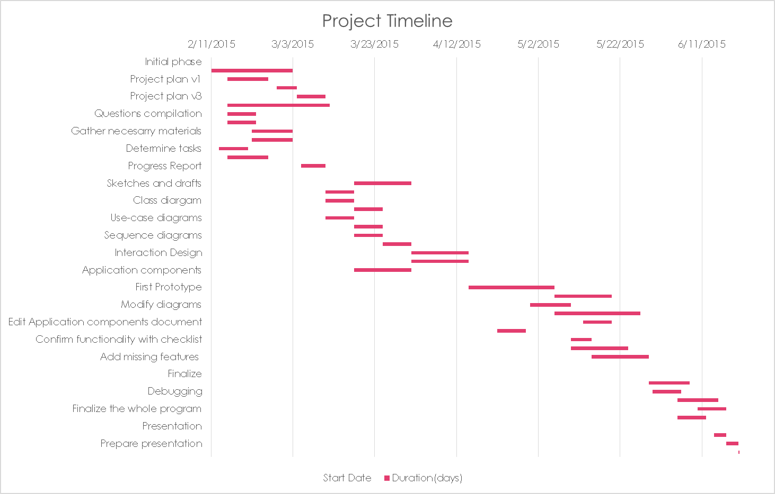

## 

# 2.2 Milestones

|  |  |
| --- | --- |
| Deliverables | |
| Milestone 1: | * Project plan, Test Plan. * URS Document. * Detailed division of work among the team members. |
| Milestone 2: | * Installed Visual Studio 2012, on computers of all developers, and acquaintance of that programs. * Design Document, Visual Design (GUI Interface). |
| Milestone 3: | * Prototype. * Creating updated and stable version. |
| Milestone 4: | * Stable prototypes according to the Test Plan. * Give the test results, so new update can be performed. * Give a final test to the last version of the application (errors, exceptions, crashes, design issues). * A list of future updates and issues that need to be fixed in the future. |
| Milestone 5: | * Deploy the source code. * Present the system. * A deployed system consisting of the C# application on the company’s computers. |

4 Management plan

#### **MOSQUITO**

Money

## Expenses:

Software:

- Visual Studio 2012 with MSDN € 4000

- Windows 7 € 300

- Office 2013 € 8 per month

Programming:

- Design € 0

- Programming € 0

- Implementation € 0

- License € 0 per year

- Maintenance € 0 per year

Backup space € 25 per month

Testing:

- Test environment setup € 250

- Testing € 200

Implementation:

- Server rollout € 0

- Support € 0

- Implementation € 0

Documentation and instruction:

- User Manual € 50

____________________________________________________

Total initial cost: € 5008

Total maintenance cost: € 65 per month

## 2. Profit:

* Doesn’t need to hire additional personnel.
* Saves up time and effort for the organizers.
* Saves up money for paper.

## 3. Additional benefits:

* All the information is stored in one place.(efficient and reliable)
* Back-up information.

## Skill

In this project we need and we can help to improve following skills:

* Organization skills.-The project leader will be in charge of organizing the project as a whole and also personnel working on the project. We will need this skill for the whole duration of the project.
* Communication skills.-We will need this skill to correspond between the team members. The better communication we have the less likely is that misunderstanding will occur. We will need this skill during the whole duration of the project.
* Customer representative.-We will need a solid connection between the client and the group so that information regarding the needs of the client can be layout as best as can.
* Programming skills.-We will need this skill to create the applications for the traffic situation.
* Coordination skill. -We will need to learn to collaborate in this project. Good coordination can make the project smoothly.

## Quality

Quality constrains:

In this project, we are going to simulate some traffic lights with some different circumstances, so it should at least be:

* + Should not give any error when the application is running.
  + Should be controllable (better easy to control)
  + Should have different types of cross.
  + Should be easy to make some demonstration.

Time

|  |  |  |  |
| --- | --- | --- | --- |
|  | **Start Date** | **Duration(days)** | **End Date** |
| **Initial phase** |  |  |  |
| Research project | 11.2.2015 | 20 | 2.3.2015 |
| Project plan v1 | 15.2.2015 | 10 | 24.2.2015 |
| Project plan v2 | 27.2.2015 | 5 | 3.3.2015 |
| Project plan v3 | 4.3.2015 | 7 | 10.3.2015 |
| Brainstorm Ideas | 15.2.2015 | 25 | 15.3.2015 |
| Questions compilation | 15.2.2015 | 7 | 21.2.2015 |
| Research what kind of software is needed | 15.2.2015 | 7 | 21.2.2015 |
| Gather necesarry materials | 21.2.2015 | 10 | 30.2.2015 |
| Install needed software | 21.2.2015 | 10 | 30.2.2015 |
| Determine tasks | 13.2.2015 | 7 | 19.2.2015 |
| Assign tasks | 15.2.2015 | 10 | 24.2.2015 |
| Progress Report | 5.3.2015 | 6 | 10.3.2015 |
| **Design phase** |  |  |  |
| Sketches and drafts | 18.3.2015 | 14 | 31.3.2015 |
| Functionality description | 11.3.2015 | 7 | 17.3.2015 |
| Class diargam | 11.3.2015 | 7 | 17.3.2015 |
| Class diargam v2 | 18.3.2015 | 7 | 24.3.2015 |
| Use-case diagrams | 11.3.2015 | 7 | 17.3.2015 |
| Use-case diagrams v2 | 18.3.2015 | 7 | 24.3.2015 |
| Sequence diagrams | 18.3.2015 | 7 | 24.3.2015 |
| Sequence diagrams v2 | 25.3.2015 | 7 | 31.3.2015 |
| Interaction Design | 1.4.2015 | 14 | 14.4.2015 |
| Visual Design | 1.4.2015 | 14 | 14.4.2015 |
| Application components | 18.3.2015 | 14 | 31.3.2015 |
| **Production** |  |  |  |
| First Prototype | 15.4.2015 | 21 | 5.5.2015 |
| Simplify GUI | 6.5.2015 | 14 | 19.5.2015 |
| Modify diagrams | 30.4.2015 | 10 | 9.5.2015 |
| Reconfigure Code | 6.5.2015 | 21 | 26.5.2015 |
| Edit Application components document | 13.5.2015 | 7 | 19.5.2015 |
| Create aditional libraries if needed | 22.4.2015 | 7 | 28.4.2015 |
| Confirm functionality with checklist | 10.5.2015 | 5 | 14.5.2015 |
| Modify GUI interface | 10.5.2015 | 14 | 23.5.2015 |
| Add missing features | 15.5.2015 | 14 | 28.5.2015 |
| Second Prototype |  |  |  |
| **Finalize** |  |  |  |
| Final appearance retouch | 29.5.2015 | 10 | 7.6.2015 |
| Debugging | 30.5.2015 | 7 | 5.6.2015 |
| Checking for performance issues | 5.6.2015 | 10 | 14.6.2015 |
| Finalize the whole program | 10.6.2015 | 7 | 16.6.2015 |
| Create user manual | 5.6.2015 | 7 | 11.6.2015 |
| **Presentation** |  |  |  |
| Final program check for presentation | 14.6.2015 | 3 | 16.6.2015 |
| Prepare presentation | 17.6.2015 | 3 | 19.6.2015 |
| Present | 20.6.2015 | 1 | 20.6.2015 |

Organization

Project Leader: Responsible for the organization of the project –distributing tasks, overviewing progress, managing the documentation. Also makes sure the project is on track and on time.

Project Leader

Tutor

Testers

Designers

Developers

Secretary

Representative

Client

Representative: Responsible for communication with the client and tutor during the meetings. Serves as the role of a link between the client and the team.

Secretary: Responsible for drawing up agendas, taking meeting notes, sending out documents to the tutor, client and team members.

Developer: The developer inspires the group with innovative (and achievable) possibilities in the technical field. Investigates and makes judgments based on the functional requirements. Is responsible for the system design and its realization (hardware and software).

Designer: The designer is responsible for the inspiration resources. Makes use of existing image material like photos and videos. Also responsible for drawing up charts, diagrams and sketches. Heavily involved with the GUI of the application.

Tester: Responsible for checking functionality of the application. The tester will be debugging the prototypes and writing reports on functionality and performance issues.

# Information

|  |  |  |  |  |  |  |  |  |  |  |  |  |  |
| --- | --- | --- | --- | --- | --- | --- | --- | --- | --- | --- | --- | --- | --- |
|  | Project Plan | Weekly reports | Agenda | Design sketches | Use-case diagrams | Sequence diagrams | Flow charts | GUI frame | Program components | Work distribution | User manual | Presentation | Final report |
| Project Leader | Dr | Di | R, Di | Di, A | Di, A | Di, A | Di, A | Di, A | Di, A | Dr, S | Di | Dr | Dr |
| Tutor | R, Di | R, A | A | R | R, A | R, A | R, A | - | R, A | R | R, Di | R | R, A |
| Client | A | - | A | R, A | R | R | R | - | R | - | R, A | R, A | - |
| Designers | - | - | R, Di | Dr | Dr | Dr | Dr | Dr | Di, A | A | Di | Di | Di |
| Developers | - | - | R, Di | Di | Dr | Dr | Dr |  | Dr | A | Di | Di | Di |
| Testers | - | - | R, Di | Di | Di | Di | Di | Di | Di, A | A | Dr | Di | Di |
| Representative | R, Di | Di, A | R, Di | Di | R, Di | R | R | R | Di | A | Di | - | Di |
| Secretary | S | Dr | Dr, S | S | S | S | S | S | S | A, S | S | S | Di, S |

(Dr-Draw up, Di-Discuss, R-Receive/Read, A-Accept, S-Send)

The roles will rotate between team members during the period of the project that’s why we won’t specify names responsible for certain documents.

# Contact information:

Jiaqi Ni(2217774) e-mail:289315@student.fontys.nl phone:0613062093

Yidi Wu(2197301) e-mail:270179@student.fontys.nl phone:0642311897

Kalina Petrova(2221667) e-mail:292607@student.fontys.nl phone:0615476508

Todor Tsekov (2228777) e-mail:296402@student.fontys.nl phone:0647795627

Wen Zhang (2351420) e-mail:301970@student.fontys.nl phone:0684304010

Jianfei Feng(2204529) e-mail:276040@student.fontys.nl phone:0610241859